**A PRELIMENERY REPORT ON**

**DIGITAL LANGUAGE LAB PORTAL**

SUBMITTED TO THE SAVITRIBAI PHULE PUNE UNIVERSITY, PUNE

IN THE PARTIAL FULFILLMENT OF THE REQUIREMENTS

FOR THE AWARD OF THE DEGREE

**BACHELOR OF ENGINEERING (COMPUTER ENGINEERING)**

##### SUBMITTED BY

GADEKAR SHUBHAM BALU Exam No : 71801732D

PAWAR ROHIT BAHUSAHEB Exam No : 71801844D

MUSALE AKSHAY DADASAHEB Exam No : 71939404L



## DEPARTMENT OF COMPUTER ENGINEERING

## SHRI CHHATRAPATI SHIVAJI MAHARAJ COLLEGE OF ENGINEERING

**NEPTI, AHMEDNAGAR**

## SAVITRIBAI PHULE PUNE UNIVERSITY

## 2020-21



**CERTIFICATE**

This is to certify that the project report entitles

**“DIGITAL LANGUAGE LAB PORTAL”**

Submitted by

GADEKAR SHUBHAM BALU Exam No : 71801732D

PAWAR ROHIT BAHUSAHEB Exam No : 71801844D

MUSALE AKSHAY DADASAHEB Exam No : 71939404L

is a bonafide student of this institute and the work has been carried out by him/her under the supervision of **Prof. A. B. C** and it is approved for the partial fulfillment of the requirement of Savitribai Phule Pune University, for the award of the degree of **Bachelor of Engineering** (Computer Engineering).

**(Prof. Darekar .S.A)** **(Prof. )**

Guide External Examiner

Department of Computer Engineering

**(Prof. J.U. Lagad ) (Dr.M.P.Nagarkar )**

Head Principal COE Department of Computer Engineering Shri Chhatrapati Shivaji Maharaj

Place : Ahmednagar

Date :

**ACKNOWLEDGEMENT**

We take this opportunity to express my hearty thanks to all those who helped me in the completion of the Project stage -1 on this topic. We would especially like to express my sincere gratitude to Prof **Darekar .S.A** my Guide and HOD Department of Computer Engineering who extended their moral support, inspiring guidance and encouraging independence throughout this task. We would also thank our Principal Dr. M.P.Nagarkar for his great insight and motivation. Last but not least, we would like to thank my fellow colleagues for their valuable suggestions.

**NAME OF THE STUDENTS**

Gadekar shubham balu exam no: 71801732d

pawar rohit bahusaheb exam no : 71801844d

musale akshay dadasaheb exam no : 71939404l

**ABSTRACT**

These is web as well as android application help to conducts schools and colleges in online mode. These application makes task easy such as upload documents, videos, pdf regarding syllabus and study material. By using these application teachers get online exam and generate result quick as possible. Student also conduct missed lectures beyond limit of place and time.

Student conduct live lectures and lecture whose missed due to some reasons. Student get regular notification on app regarding college, department and exam. Student also conduct exams in online mode and get result quick. These application also helpful to submit assignment and practical work online to teachers.

**TABLE OF CONTENTS**

LIST OF ABBREVATIONS i

LIST OF FIGURES ii

LIST OF TABLES iii

|  |  |  |  |  |  |  |
| --- | --- | --- | --- | --- | --- | --- |
| **SR.NO.** | | | | **TITLE OF CHAPTER** | | **PAGE NO.** |
| 01 | | | | **Introduction** | | 9 |
|  | 1.1 | | | **Motivation** | | 9 |
|  | 1.2 | | | **Problem Definition** | | 9 |
| 02 | | | | **Literature Survey** | | 10 |
| 03 | | | | **Software Requirements Specification** | | 14 |
|  | | 3.1 | | Introduction | | 14 |
|  | |  | | 3.1.1 | Project Scope | 14 |
|  | |  | | 3.1.2 | User Classes and Characteristics | 14 |
|  | |  | | 3.1.3 | Assumptions and Dependencies | 14 |
|  | | 3.2 | | **Functional Requirements** | | 15 |
|  | |  | | 3.2.1 | System Feature 1(Functional Requirement) | 15 |
|  | | 3.4 | | **Nonfunctional Requirements** | | 15 |
|  | |  | | 3.4.1 | Performance Requirements | 15 |
|  | |  | | 3.4.2 | Safety Requirements | 15 |
|  | |  | | 3.4.3 | Security Requirements | 15 |
|  | |  | | 3.4.4 | Software Quality Attributes | 15 |
|  | | 3.5 | | **System Requirements** | | 15 |
|  | |  | | 3.3.1 | Database Requirements | 16 |
|  | |  | | 3.3.2 | Software Requirements(Platform Choice) | 16 |
|  | |  | | 5.3.3 | Hardware Requirements | 16 |
|  | | 3.6 | | **Analysis Models: SDLC Model to be applied** | | 17 |
|  | | 3.7 | | **System Implementation Plan** | | 17 |
| 04 | | | | **System Design** | | 18 |
|  | | 4.1 | | System Architecture | | 18 |
|  | | 4.2 | | Data Flow Diagrams | | 19 |
|  | | 4.3 | | Entity Relationship Diagrams | | 20 |
|  | | 4.4 | | UML Diagrams | | 21 |
| 05 | | | | Project Plan | | 34 |
|  | | | 5.1 | Project Estimate | | 34 |
|  | | |  | 5.1.1 Reconciled Estimates | | 34 |
|  | | |  | 5.1.2 Project Resources | | 34 |
|  | | | 5.2 | Risk Management | | 34 |
|  | | | | 5.2.1 Risk Identification | | 34 |
|  | | | | 5.2.2 Risk Analysis | | 35 |
|  | | | | 5.2.3 Overview of Risk Mitigation, Monitoring, Management | | 35 |
|  | | | 5.3 | Project Schedule | | 35 |
|  | | | | 5.3.1 Project Task Set | | 36 |
|  | | | | 5.3.2 Task Network | | 36 |
|  | | | | 5.3.3 Timeline Chart | | 37 |
|  | | | 5.4 | Team Organization | | 38 |
|  | | | | 5.4.1 Team structure | | 38 |
|  | | | | 5.4.2 Management reporting and communication | | 39 |
| 06 | | | | Project Implementation | | 40 |
|  | | | 6.1 | Overview of Project Modules | | 40 |
|  | | | 6.2 | Tools and Technologies Used | | 40 |
| 6.3 | | |  | Algorithm Details | | 41 |
|  | | | | 6.3.1 Binary Search | | 41 |
|  | | | | 6.3.2 View Processing Algorithms Mysql | | 41 |
|  | | | | 6.3.3 ORDER BY Optimization | | 41 |
| 07 | | | | Software Testing | | 42 |
|  | | | 7.1 | Type of Testing | | 42 |
|  | | | 7.2 | Test cases & Test Results | | 45 |
| 08 | | | | Results | | 47 |
|  | | | 8.1 | Outcomes | | 47 |
|  | | | 8.2 | Screen Shots | | 48 |
| 09 | | | | **Conclusion** | | 54 |
|  | | 9.1 | | Conclusions | | 54 |
|  | | 9.2 | | Future Work | | 54 |
|  | | 9.3 | | Applications | | 54 |
|  | |  | |  | |  |

**LIST OF ABBREVATIONS**

|  |  |
| --- | --- |
| **Abbreviation** | **Illustration** |
|  |  |
| VPN | Virtual Private Network |
| IP | Internet Protocol |
| IDS | Intrusion Detection System |
| TCP | Transmission Control Protocol |

**LIST OF FIGURES**

|  |  |  |
| --- | --- | --- |
| **Figure** | **Illustration** | **Page No.** |
| 1.1 | System Behavior | 18 |
| 2.1 | DFD Level – 0 | 19 |
| 2.2 | DFD Level – 1 | 20 |
| 2.3 | DFD Level – 2 | 21 |
| 3.1 | Use case Diagram | 23 |
| 3.1 | Sequence Diagram | 24 |
| 3.2 | ER Diagram | 22 |
| 3.3 | Class Diagram | 24 |
| 3.4 | Component Diagram | 25 |
| 3.5 | Deployment Diagram | 26 |

**LIST OF TABLES**

|  |  |  |
| --- | --- | --- |
| **Table** | **Illustration** | **Page No.** |
| 1.1 | Admin Login | 29 |
| 1.2 | Course Document | 29 |
| 1.3 | Course Meeting | 30 |
| 1.4 | Course Registration | 30 |
| 1.5 | Exam | 31 |
| 1.6 | Lecture Video | 31 |
| 1.7 | Notification | 31 |
| 1.8 | Question | 32 |
| 1.9 | Result | 32 |
| 1.10 | Saved Answer | 33 |
| 1.11 | Test | 33 |

**INTRODUCTION**

**MOTIVATION**

Now a days we are see all education facilities being in online mode. Due to many reasons student are unable to conduct lecture in physical classroom so we need to design a system such a way that these system make work simple and beyond the limit of space and time. By using these portal student can conduct lecture in online mode and also conduct lecture whose are missed by some reason. Student get all notification in their applications and also submit assignment, attend the exam. These system also helpful for teacher to examine the student progress by view their reports and also generate report on one click.

**PROBLEM DEFINITION**

Now a day schools and colleges conduct in online mode so student needed online lectures and documentation regarding syllabus, topics. These application help to student as well as teachers or faculty to manage online lectures. Teachers provides online pdf, videos, and other documents. Also conduct online exam for student and quick generate results.

**LITERATURE SURVEY**

Fakhrurrazi M. Amin, Hanna Sundari

English Teaching Department, State Institute for Islamic Studies (IAIN) Langsa, Langsa 24411, INDONESIA and English Education Department, Indraprasta PGRI University, Jakarta 12530, INDONESIA

Abstract

The use of technology in language learning has extensively expanded in line with the advancement of technology itself. However, the investigation into the implementation of video conferences, learning management systems, and mobile applications, particularly during the emergency remote teaching/the Covid-19 pandemic, is still lacking. This paper presents survey data from three groups of Indonesian EFL students using three different digital learning platforms: Cisco WebEx Meeting video conferencing, Google Classroom learning management system (LMS), and WhatsApp mobile messenger application. The purpose of the study was to determine the students’ preferences including their perception and point of views on using the platforms and application during the remote teaching situation.

Introduction

On March 11, 2020, the World Health Organization (WHO) announced that the novel coronavirus (Covid-19) outbreak had become a worldwide pandemic because the cases outside China rose 13 times and the number of countries with cases increased threefold over two weeks (Cucinotta & Vanelli, 2020). Several days later, as reported by UN Educational, Scientific and Cultural Organization on March 18, 2020, approximately 107 countries had implemented national school closures concerning to this pandemic that has impacted 862 million children and young people around the world (Viner et al., 2020). The policy was to curb the widespread of the virus and to reduce the transmission and the number of cases. In Indonesia, in the middle of March 2020, most schools and universities have been closed along with the presidential briefing and campaign to work, learn, and worship from home. Officially, as cited from https://www.thejakartapost.com/ by Sutrisno (2020), the Indonesian government has issued two regulations, they are government regulation and Health Ministry regulation by early April to apply a largescale social restriction (Pembatasan Sosial Berskala Besar or PSBB); it equals to partial lockdown. As a consequence, offices, schools, universities, and worship places have to close, and people move into online activities through Work from Home and Learn from Home agenda. In the educational sector, some schools and universities have applied the policy of remote teaching and online learning (Purwanto et al., 2020). It resulted in a situation where teachers and students are undesirably asked to change their teaching system from the offline face-to-face session in the classroom into a digital/virtual teaching system using various online platforms or applications. They must quickly learn and adapt their teaching and learning management to cope with this unprecedented situation. Likewise, an adjustment in teaching materials, media, and assessments is highly needed to be performed immediately. Teachers and students in the field of English as a foreign language have no differences in handling it

Results

This current paper was addressed to describe the students’ preferences on the use of the Cisco WebEx Meeting (CWE), Google Classroom (GC), and WhatsApp (WA) among three different groups of student-participants during ERT/the Covid-19 pandemic. The results were presented based on six criteria of CALL evaluation and responses upon opened questions among the three platforms and applications. The first criterion was the language learning potential. It explores the learning opportunity focusing on material delivery and language exercise that allows students to learn a language. Based on the result in Table 4, WhatsApp got the highest percentage on material delivery, but GC gained on top of presenting language exercise. Not only that, almost half of participants on each group-participant, 44%-61% of them, perceived that the digital platforms they used during ERT were as beneficial and potential in language learning.

CONCLUSION

This current study was to explore the students’ preferences on digital learning platforms during the emergency remote teaching. The major finding shows that the student-participants at each group of three digital platforms on the survey, Cisco WebEx Meeting video conferencing, Google Classroom learning management system, and WhatsApp mobile messenger application perceives positive agreement and feel much learning and improvement though it was in an unprecedented situation. Approximately 44%-61% of the student-participant at each group agreed that the platform they used was beneficial and potential for language learning. F. M. Amin, & H. Sundari, EFL students’ preferences on digital platforms during emergency remote teaching: Video Conference, LMS, or Messenger Application? | 375 For Cisco WebEx video conferencing, it scored within 73 to 84 for all six criteria. Authenticity received the highest score. It indicates that the student-participants felt Cisco WebEx help them learn using the real language for communication. Meanwhile, Google Classroom LMS achieved 74 to 95 in six criteria; the lowest score on positive impact and the highest score on language learning potential. This shows that the student-participant who used Google Classroom found that it brings good potential as a language learning tool, but they may feel doubt to use it for the next course. The use of Google Classroom might need to be accompanied by other platforms or applications to create a more communicative and interactive session. On the other hand, the WhatsApp mobile messenger application receives more positive agreement and preferences in four out of six criteria: meaning focus, learner fit, positive impact, and practicality. The student-participants facilitated by WhatsApp perceived that this application is practical and suitable for them in the term of age, preferences, and style.

**SOFTWARE REQUIREMENTS SPECIFICATION**

**INTRODUCTION**

Project Scope

Online learning is a wide platform to help students get more educated. With the E-Learning, the concept of learning has differed from the old times. This portal is widely increased as the each individual contains a smart phone with high speed internet through which, each can access the courses on the portal in minutes. Some report engines like KPMG released their research that, by the year 2021, the count of people who were using the e-learning platform can reach up to 9.6 million. This figure is huge in number. In order to help learners to get more knowledgeable. These portal creating more interest to students with their new courses, practical etc. This learning platform is creating its type of awareness which is available to the villages and all the cities.

User Classes and Characteristics

* New Registration
* Apply for Course
* View Documents and PDF
* View Media and Lectures
* Edit Profile
* Conduct Exam
* Submit Assignment’s and work
* View Result

Assumptions and Dependencies

It refers to those factors that are assumed to be certain for the purpose of costing and planning. Some of the assumptions are duration of the course, duration of the course audio, client review days and so on.

**Functional Requirements**

System Feature 1

The term client/server refers primarily to an architecture or logical division of responsibilities, the client is the application (also known as the front-end), and the server is the DBMS (also known as the back-end). A client/server system is a distributed system in which.

* Some sites are client sites and others are server sites.
* All the data resides at the server sites.
* All applications execute at the client sites.

**Nonfunctional Requirements**

Performance Requirements

The basic objective of normalization is to reduce redundancy which means that information is to be stored only once. Storing information several times leads to wastage of storage space and increase in the total size of the data stored. Performance depends on how transaction is done on server side.

Safety Requirements

If there is extensive damage to a wide portion of the database due to catastrophic failure, such as a disk crash, the recovery method restores a past copy of the database that was backed up to archival storage (typically tape) and reconstructs a more current state by reapplying or redoing the operations of committed transactions from the backed up log, up to the time of failure.

Security Requirements

Security systems need database storage just like many other applications. However, the special requirements of the security market mean that vendors must choose their database partner carefully.

Software Quality Attributes

* **AVAILABILITY:** The flight should be available on the specified date and specified time as many customers are doing advance reservations.
* **CORRECTNESS:** The flight should reach start from correct start terminal and should reach the correct destination.
* **MAINTAINABILITY:** The administrators and flight in chargers should maintain correct schedules of flights.
* **USABILITY:** The flight schedules should satisfy a maximum number of customers needs.

**System Requirement’s**

Database Requirements

* Mysql Database

Software Requirements(Platform Choice)

* Php (8.1)
* HTML, Java Script
* Android

Hardware Requirements

* Android 5.0 and Later
* Windows XP and Later
* HDD 120GB and Later
* RAM 256MB and Later

Analysis Models: SDLC Model to be applied

As implied in the waterfall SDLC models, the first phase of the development is analysis phase. Observation and interview have been conducted in SLC. The observation and interview conducted are to gain information and the better understanding of the problem and the needs that SLC has. Then, in the second phase or design phase, Unified Modelling Language (UML) is used to design the software architecture. The diagrams used in this phase are use case diagram, sequence diagram, activity diagram, and class diagram. After the class diagram is produced, data modeling is performed using entity relationship diagram. For the third phase or implementation, the application is developed from scratch concept using PHP. The part of the system that manages all tasks related to data like validation, session state, control, and data source structure (database). These model greatly reduces the complexity of the code the developer needs to write. The model layer is responsible for the business logic of an application. It will encapsulate

System Implementation Plan

First we need to normalize data which gather from requirements techniques. From these gather data we design database and decide attribute of database. Once database is design we are ready creates form for application. After creating all form these form are connected to each other. Once all form are connected we write logics for that forms.

**SYSTEM DESIGN**

**System Architecture**

**Database**

**USERS**

Course creation

Student Management

Exam Management

Manage media and document

**Admin Management**

Student Registration

Edit Profile

View Media

Attend Exam

**Student Management**

**MySQL Database (Backend Management)**

Figure system architecture

**Data Flow Diagrams**

**Level 0**

Registration

Figure DFD Level 0

No

No

Yes

Yes

Student Dashboard

Admin Dashboard

Student

Admin

Level 1

Figure DFD Level 1

Figure DFD Level 1

Admin Dashboard

Student Dashboard

Level 2

Admin Dashboard

Figure DFD Level 2

Work Table

Media Table

Exam Table

Student Dashboard

Exam Table

Course Table

Media Table

**Entity Relationship Diagrams**

Figure ER-Diagram

Course

Media

Exam

Manage

User

Roles

Permission

Has

**UML Diagrams**

Use Case Diagram

System Boundary

Figure use case diagram

DLLP system

Student

Admin

Sequence Diagram

Figure Sequence Diagram

18 Display Result

17 generate results

16 save to database

13 Add Exam

15 Conduct Exam

14 save to database

12 Display Course

11 Display Media

10 Display Notification

9 fetch data from database

8 save to database

7 Add notification

6 save to database

5 Upload Media

1 user login

4 save to database

3 Add course

2 check credential

Database

DLLP system

User

Component Diagram

Figure Component Diagram

Web Browser

Application

<<component>>

Authentication

<<component>>

User

<<component>>

Exam

<<component>>

Media

Database

Deployment Diagram

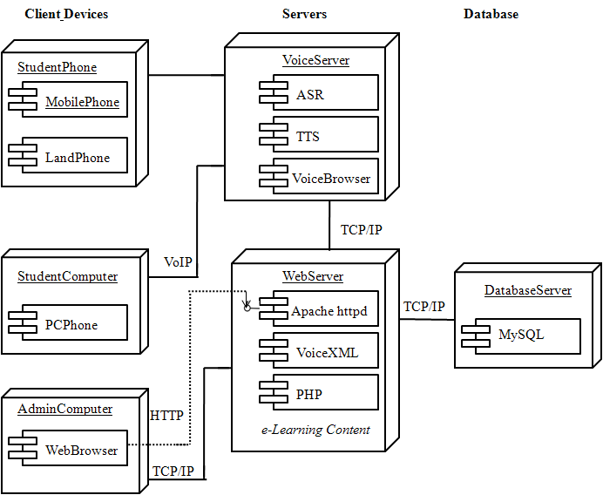

Figure Deployment Diagram

**DLLP**

HTTP

**Database**

**Server**

**Client Device**

Class Diagram

Figure Class Diagram

1

1

M

M

M

M

M

M

M

M

M

M

M

M

1

1

+ display_result()

Result

-result_id

- result _name

-exam_id

- exam _name

Exam

+ update_ exam ()

+ edit_ exam ()

+ delete_ exam ()

-media_id

- media _name

- media_type

+ update_ media ()

+ edit_ media ()

+ delete_ media ()

Media

Course

-course_id

-course_name

+ update_course()

+ edit_course()

+ delete_course()

Student

-student_id

-student_name

-password

-username

+ enrole_course()

+ view_media()

+ conduct_exam()

+ add_course()

+ add_media()

+ add_exam()

Admin

-userid

-username

-password

|  |  |  |  |  |  |
| --- | --- | --- | --- | --- | --- |
| **Name** | **Collation** | **Attributes** | **Null** | **Default** | **Comments** |
| **id** | int(20) |  |  | No | *None* |
| **a_username** | varchar(200) | latin1_swedish_ci |  | No | *None* |
| **a_password** | varchar(200) | latin1_swedish_ci |  | No | *None* |

**DATABASE TABLES**

admin_login

course_document

|  |  |  |  |  |  |
| --- | --- | --- | --- | --- | --- |
| **Name** | **Collation** | **Attributes** | **Null** | **Default** | **Comments** |
| **document_id** | int(20) |  |  | No | *None* |
| **upload_date** | varchar(100) | latin1_swedish_ci |  | No | *None* |
| **course_id** | int(20) |  |  | No | *None* |
| **document_title** | varchar(200) | latin1_swedish_ci |  | No | *None* |
| **document_description** | varchar(500) | latin1_swedish_ci |  | No | *None* |
| **document_path** | varchar(300) | latin1_swedish_ci |  | No | *None* |

Course_meeting

|  |  |  |  |  |  |
| --- | --- | --- | --- | --- | --- |
| **Name** | **Collation** | **Attributes** | **Null** | **Default** | **Comments** |
| **meeting_id** | int(20) |  |  | No | *None* |
| **meeting_date** | varchar(45) | latin1_swedish_ci |  | No | *None* |
| **course_id** | int(20) |  |  | No | *None* |
| **course_name** | varchar(200) | latin1_swedish_ci |  | No | *None* |
| **meeting_time** | varchar(45) | latin1_swedish_ci |  | No | *None* |
| **meeting_zoomid** | varchar(500) | latin1_swedish_ci |  | No | *None* |
| **meeting_password** | varchar(200) | latin1_swedish_ci |  | No | *None* |
| **status** | varchar(100) | latin1_swedish_ci |  | No | *None* |

Course_registration

|  |  |  |  |  |  |
| --- | --- | --- | --- | --- | --- |
| **Name** | **Collation** | **Attributes** | **Null** | **Default** | **Comments** |
| **registration_id** | int(20) |  |  | No | *None* |
| **registration_date** | varchar(100) | latin1_swedish_ci |  | No | *None* |
| **student_name** | varchar(200) | latin1_swedish_ci |  | No | *None* |
| **mobile_no** | varchar(45) | latin1_swedish_ci |  | No | *None* |
| **email_id** | varchar(200) | latin1_swedish_ci |  | No | *None* |
| **qualification** | varchar(200) | latin1_swedish_ci |  | No | *None* |
| **full_address** | varchar(2000) | latin1_swedish_ci |  | No | *None* |
| **status** | varchar(200) | latin1_swedish_ci |  | No | *None* |
| **username** | varchar(200) | latin1_swedish_ci |  | No | *None* |
| **password** | varchar(200) | latin1_swedish_ci |  | No | *None* |

Exam

|  |  |  |  |  |  |
| --- | --- | --- | --- | --- | --- |
| **Name** | **Collation** | **Attributes** | **Null** | **Default** | **Comments** |
| **exam_id** | int(20) |  |  | No | *None* |
| **student_id** | int(20) |  |  | No | *None* |
| **test_id** | int(20) |  |  | No | *None* |
| **exam_date** | varchar(100) | latin1_swedish_ci |  | No | *None* |

Lecture_video

|  |  |  |  |  |  |
| --- | --- | --- | --- | --- | --- |
| **Name** | **Collation** | **Attributes** | **Null** | **Default** | **Comments** |
| **lecture_video_id** | int(20) |  |  | No | *None* |
| **upload_date** | varchar(100) | latin1_swedish_ci |  | No | *None* |
| **course_id** | int(20) |  |  | No | *None* |
| **video_title** | varchar(200) | latin1_swedish_ci |  | No | *None* |
| **video_description** | varchar(500) | latin1_swedish_ci |  | No | *None* |
| **video_path** | varchar(200) | latin1_swedish_ci |  | No | *None* |

Notification

|  |  |  |  |  |  |
| --- | --- | --- | --- | --- | --- |
| **Name** | **Collation** | **Attributes** | **Null** | **Default** | **Comments** |
| **notification_id** | int(20) |  |  | No | *None* |
| **upload_date** | varchar(100) | latin1_swedish_ci |  | No | *None* |
| **text_message** | varchar(500) | latin1_swedish_ci |  | No | *None* |
| **status** | varchar(200) | latin1_swedish_ci |  | No | *None* |

Questions

|  |  |  |  |  |  |
| --- | --- | --- | --- | --- | --- |
| **Name** | **Collation** | **Attributes** | **Null** | **Default** | **Comments** |
| **question_id** | int(20) |  |  | No | *None* |
| **test_id** | int(20) |  |  | No | *None* |
| **question** | varchar(500) | latin1_swedish_ci |  | No | *None* |
| **option_a** | varchar(500) | latin1_swedish_ci |  | No | *None* |
| **option_b** | varchar(500) | latin1_swedish_ci |  | No | *None* |
| **option_c** | varchar(500) | latin1_swedish_ci |  | No | *None* |
| **option_d** | varchar(500) | latin1_swedish_ci |  | No | *None* |
| **answer** | varchar(200) | latin1_swedish_ci |  | No | *None* |
| **mark** | varchar(200) | latin1_swedish_ci |  | No | *None* |

Result

|  |  |  |  |  |  |
| --- | --- | --- | --- | --- | --- |
| **Name** | **Collation** | **Attributes** | **Null** | **Default** | **Comments** |
| **result_id** | int(20) |  |  | No | *None* |
| **exam_id** | int(20) |  |  | No | *None* |
| **student_id** | int(20) |  |  | No | *None* |
| **result_date** | varchar(200) | latin1_swedish_ci |  | No | *None* |
| **total_question** | varchar(200) | latin1_swedish_ci |  | No | *None* |
| **correct_answer** | varchar(200) | latin1_swedish_ci |  | No | *None* |
| **worng_answer** | varchar(200) | latin1_swedish_ci |  | No | *None* |
| **total_marks** | varchar(200) | latin1_swedish_ci |  | No | *None* |
| **outof_marks** | varchar(200) | latin1_swedish_ci |  | No | *None* |
| **percentage** | varchar(200) | latin1_swedish_ci |  | No | *None* |
| **grade** | varchar(200) | latin1_swedish_ci |  | No | *None* |

Saved_answer

|  |  |  |  |  |  |
| --- | --- | --- | --- | --- | --- |
| **Type** | **Collation** | **Attributes** | **Null** | **Default** | **Comments** |
| **save_id** | int(20) |  |  | No | *None* |
| **exam_id** | int(20) |  |  | No | *None* |
| **test_id** | int(20) |  |  | No | *None* |
| **question_id** | int(20) |  |  | No | *None* |
| **saved_option** | varchar(20) | latin1_swedish_ci |  | No | *None* |
| **correct_answer** | varchar(20) | latin1_swedish_ci |  | No | *None* |
| **marks** | varchar(200) | latin1_swedish_ci |  | No | *None* |

Test

|  |  |  |  |  |  |
| --- | --- | --- | --- | --- | --- |
| **Name** | **Collation** | **Attributes** | **Null** | **Default** | **Comments** |
| **test_id** | int(20) |  |  | No | *None* |
| **create_date** | varchar(100) | latin1_swedish_ci |  | No | *None* |
| **exam_title** | varchar(200) | latin1_swedish_ci |  | No | *None* |
| **subject_name** | varchar(200) | latin1_swedish_ci |  | No | *None* |
| **no_of_question** | varchar(200) | latin1_swedish_ci |  | No | *None* |
| **total_marks** | varchar(200) | latin1_swedish_ci |  | No | *None* |
| **exam_timing** | varchar(200) | latin1_swedish_ci |  | No | *None* |
| **status** | varchar(200) | latin1_swedish_ci |  | No | *None* |

**PROJECT PLAN**

**Project Estimate**

Reconciled Estimates

Developing an app takes time and dedication. Of course, the time and price would depend on the features of projects. To provide you with a rough estimation, the time needed is around 180-200 hours and cost varies between 6000RS to 8000 RS.

**Project Resources**

Client Side

* HTML (Hyper Text Markup Language)
* CSS (Cascading Style Sheets)
* JavaScript Ajax (Asynchronous JavaScript and XML)
* jQuery (JavaScript Framework Library – commonly used in Ajax development)

Server Side

* PHP (very common Server Side Scripting language – Linux / Unix based Open Source – free redistribution, usually combines with MySQL database)

**Risk Management**

Risk Identification

Many things can happen to compromise data-safety and application reliability. Some of these are common and some are rare, but it’s a fact that they’re inevitable. You *cannot* avoid malicious users from trying to exploit the holes in your application’s armor.

For instance, a *Denial of Service* (DoS) attack can take your service offline by overloading the traffic your servers can take. In practice, these attacks are distributed (Distributed DoS, or DDoS for short) over a large network of attackers, making them even harder to track down. These attacks are countered with filtering and picking out the invalid connections and denying them access to the service.

Another common attack is the *Man-in-the-middle* (MitM) attack, where a malicious user acts as a middleman between the data being sent between a client (user) and your servers.

There are multiple types of MitM attacks such as ARP Spoofing, IP Spoofing and DNS Spoofing. Furthermore, they can *sniff* the data being sent, *hijack* the session and take control of it or even *inject* packets to compromise the original data package.

This data can be trivial, but it can also be highly sensitive – like credit card or personal information.

Database-driven services are more prone to *SQL Injection* attacks, where an unwanted user gains privileges in your database. It’s enough to have the most basic database privileges to be able to extract enough information to cause havoc, depending on how sensitive the data is.

Risk Analysis

The first step for achieving effective risk management is to create a list of the risks that your web application faces. If your application transfers sensitive information between clients and servers – expect a MitM attack. If your application sends a lot of emails with attachments – expect a Phishing attack. If your application handles time-based transactions, such as stock market brokers – a DDoS attack can turn everything upside down. Next, you will need to *quantify* the risks that the application faces. Quantification makes it easy to compare risks, identify the most impactful ones, and pick suitable risk control measures.

Overview of Risk Mitigation, Monitoring, Management

Different risks can be treated differently by your business, depending on the available resources and the impact that the risk can have. There are four risk treatment options - transferring the risk, mitigating it, ignoring it, and accepting it.

Of course, a certain amount of in-house solutions to common problems shouldn’t be hard to implement – such as encrypting transfer data, using secure transfer mediums, hashing passwords, etc.

If a risk is too trivial to have an impact, you should ignore it. For risks that can't maim your web development process and application, without you having solutions to them, you should completely ignore them.

**Project Schedule**

Project Task Set

1. Define the goals and objectives of your site.
2. Create a wireframe.
3. Organize your content and create a content list.
4. Create a task list.
5. Set a timeline.
6. Establish a budget.
7. Assemble a team.

Task Network

1. Data Normalization
2. Database Design
3. Form Design
4. Form Interconnection
5. Write Actual Logic
6. Testing Application

Timeline Chart

Generate Report

24-30 Hour

Testing

24-30 Hour

Logic Implementation

100-120 Hour

Form Connection

4-5 Hour

Form Design

24-48 Hour

Database Design

6-7 Hour

Data Normalization

6-7 Hour

**Team Organization**

Team structure

Logic Implementation

Testing Work

Form Design

Form Connection

Report Creation

Database Normalization

Database Design

Gadekar Shubham Balu

Musale Akshay Dadasaheb

Pawar Rohit Bahusaheb

Team Structure

Management reporting and communication

* Current deliverables status with reference to the schedule progress and costs incurred.
* Comparisons between actual and planned values related to technical performance, cost performance and schedule performance.
* Performance report formats and templates.
* Policies and rules applied to creation of the performance report.
* Measures and indicators to be used in the report.
* Communication methods and techniques used during the project managing process.
* Variance analysis that allows identifying the difference between the baseline and actual performance. Variance analysis includes information on the project quality, the resources consumed, the working time spent. The analysis also lets define the impact of the variances.
* Forecasting methods that allow considering time, casual metrics, intuitive judgment and other information to estimate future outcomes.
* Reporting system for capturing, storing and distributing performance reports.

**PROJECT IMPLEMENTATION**

Overview of Project Modules

Following Modules are used in projects

* New Registration
* Apply for Course
* View Documents and PDF
* View Media and Lectures
* Edit Profile
* Conduct Exam
* Submit Assignment’s and work
* View Result

Tools and Technologies Used

* Mysql Database
* Php (8.1)
* HTML, Java Script
* Android Studio
* Sublime Text Editor

Algorithm Details

* Binary Search

These algorithms are specifically designed for searching in sorted data structures. These type of searching algorithms are much more efficient than Linear Search as they repeatedly target the center of the search structure and divide the search space in half.

* View Processing Algorithms Mysql

The optional algorithm clause for CREATE VIEW or ALTER VIEW is a MySQL extension to standard SQL. It affects how MySQL processes the view. Algorithm takes three values: MERGE, TEMPTABLE, or UNDEFINED.

* ORDER BY Optimization

This section describes when MySQL can use an index to satisfy an ORDER BY clause, the filesort operation used when an index cannot be used, and execution plan information available from the optimizer about ORDER BY.

**SOFTWARE TESTING**

Type of Testing

**1. Unit Testing**

It focuses on the smallest unit of software design. In this, we test an individual unit or group of interrelated units. It is often done by the programmer by using sample input and observing its corresponding outputs.

**2. Integration Testing**

The objective is to take unit tested components and build a program structure that has been dictated by design. Integration testing is testing in which a group of components is combined to produce output.

**3. Regression Testing**

Every time a new module is added leads to changes in the program. This type of testing makes sure that the whole component works properly even after adding components to the complete program.

**4. Smoke Testing**

This test is done to make sure that software under testing is ready or stable for further testing  It is called a smoke test as the testing an initial pass is done to check if it did not catch the fire or smoke in the initial switch on.

**5. Alpha Testing**

This is a type of validation testing. It is a type of *acceptance testing*which is done before the product is released to customers. It is typically done by QA people.

**6. Beta Testing**

The beta test is conducted at one or more customer sites by the end-user of the software. This version is released for a limited number of users for testing in a real-time environment

**7.System Testing**

This software is tested such that it works fine for the different operating systems. It is covered under the black box testing technique. In this, we just focus on the required input and output without focusing on internal working.   
In this, we have security testing, recovery testing, stress testing, and performance testing

**8. Stress Testing**

In this, we give unfavorable conditions to the system and check how they perform in those conditions.

**9. Performance Testing**

It is designed to test the run-time performance of software within the context of an integrated system. It is used to test the speed and effectiveness of the program. It is also called load testing. In it we check, what is the performance of the system in the given load.

Test cases & Test Results

**1.Usability Test Cases**

* Web page content should be correct without any spelling or grammatical errors
* All fonts should be same as per the requirements.
* All the text should be properly aligned.
* All the error messages should be correct without any spelling or grammatical errors and the error message should match with the field label.
* Tool tip text should be there for every field.
* All the fields should be properly aligned.
* Enough space should be provided between field labels, columns, rows, and error messages.
* All the buttons should be in a standard format and size.
* Home link should be there on every single page.
* Disabled fields should be grayed out.
* Check for broken links and images.
* Confirmation message should be displayed for any kind of update and delete operation.
* Check the site on different resolutions (640 x 480, 600x800 etc.?)
* Check the end user can run the system without frustration.
* Check the tab should work properly.
* Scroll bar should appear only if required.
* If there is an error message on submit, the information filled by the user should be there.
* Title should display on each web page
* All fields (Textbox, dropdown, radio button, etc) and buttons should be accessible by keyboard shortcuts and the user should be able to perform all operations by using keyboard.
* Check if the dropdown data is not truncated due to the field size. Also, check whether the data is hardcoded or managed via administrator.

**2.Functional Test Cases:**

* Test all the mandatory fields should be validated.
* Test the asterisk sign should display for all the mandatory fields.
* Test the system should not display the error message for optional fields.
* Test that leap years are validated correctly & do not cause errors/miscalculations.
* Test the numeric fields should not accept the alphabets and proper error message should display.
* Test for negative numbers if allowed for numeric fields.
* Test division by zero should be handled properly for calculations.
* Test the max length of every field to ensure the data is not truncated.
* Test the pop up message ("This field is limited to 500 characters") should display if the data reaches the maximum size of the field.
* Test that a confirmation message should display for update and delete operations.
* Test the amount values should display in currency format.
* Test all input fields for special characters.
* Test the timeout functionality.
* Test the Sorting functionality.
* Test the functionality of the buttons available
* Test the Privacy Policy & FAQ is clearly defined and should be available for users.
* Test if any functionality fails the user gets redirected to the custom error page.
* Test all the uploaded documents are opened properly.
* Test the user should be able to download the uploaded files.
* Test the email functionality of the system.
* Test the Java script is properly working in different browsers (IE, Firefox, Chrome, safari and Opera).
* Test to see what happens if a user deletes cookies while in the site.
* Test to see what happens if a user deletes cookies after visiting a site.
* Test all the data inside combo/list box is arranged in chronological order.

**3.Compatibility Test Cases:**

* Test the website in different browsers (IE, Firefox, Chrome, Safari and Opera) and ensure the website is displaying properly.
* Test the HTML version being used is compatible with appropriate browser versions.
* Test the images display correctly in different browsers.
* Test the fonts are usable in different browsers.
* Test the java script code is usable in different browsers.
* Test the Animated GIF's across different browsers.

**4.Database Test Cases:**

* Verify the database name: The database name should match with the specifications.
* Verify the Tables, columns, column types and defaults: All things should match with the specifications.
* Verify whether the column allows a null or not.
* Verify the Primary and foreign key of each table.
* Verify the Stored Procedure:
* Test whether the Stored procedure is installed or not.
* Verify the Stored procedure name
* Verify the parameter names, types and number of parameters.
* Test the parameters if they are required or not.
* Test the stored procedure by deleting some parameters
* Test when the output is zero, the zero records should be affected.
* Test the stored procedure by writing simple SQL queries.
* Test whether the stored procedure returns the values
* Test the stored procedure with sample input data.
* Verify the behavior of each flag in the table.
* Verify the data gets properly saved into the database after each page submission.
* Verify the data if the DML (Update, delete and insert) operations are performed.
* Check the length of every field: The field length in the back end and front end must be same.

**5. Security Test Cases:**

* Verify the web page which contains important data like password, credit card numbers, secret answers for security question etc should be submitted via HTTPS (SSL).
* Verify the important information like password, credit card numbers etc should display in encrypted format.
* Verify password rules are implemented on all authentication pages like Registration, forgot password, change password.
* Verify if the password is changed the user should not be able to login with the old password.
* Verify the error messages should not display any important information.
* Verify if the user is logged out from the system or user session was expired, the user should not be able to navigate the site.
* Verify to access the secured and non-secured web pages directly without login.
* Verify the “View Source code” option is disabled and should not be visible to the user.
* Verify the user account gets locked out if the user is entering the wrong password several times.
* Verify the cookies should not store passwords.
* Verify if, any functionality is not working, the system should not display any application, server, or database information. Instead, it should display the custom error page.
* Verify the SQL injection attacks.
* Verify the user roles and their rights. For Example, the requestor should not be able to access the admin page.
* Verify the important operations are written in log files, and that information should be traceable.
* Verify the session values are in an encrypted format in the address bar.
* Verify the cookie information is stored in encrypted format.
* Verify the application for Brute Force Attacks

**RESULTS**

Outcomes

Based on the analysis and design of Digital Language Lab Portal, it can be concluded into several points. First, with Online Learning, students have no difficulty in learning. It is because the material can be obtained through this Digital Language Lab Portal (DLLP). These learning materials can be accessed on the portal. Second, in Online Learning, the progress of the learning process can be measured through the features of lesson and quiz. Then, the learning outcomes can be viewed through member dashboard.

Screen Shots

* 1. 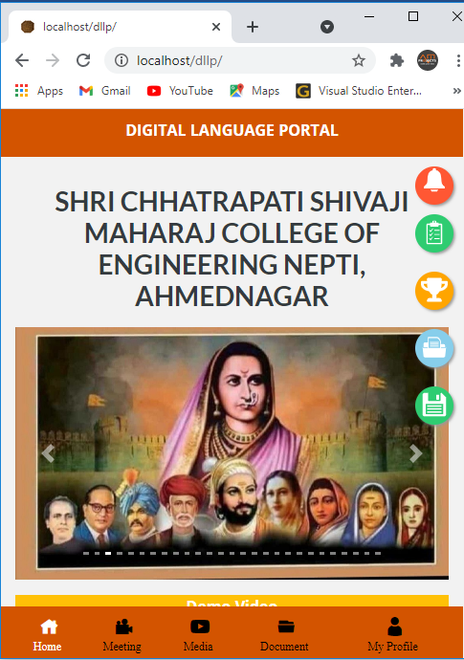Dashboard
  2. **Registration**

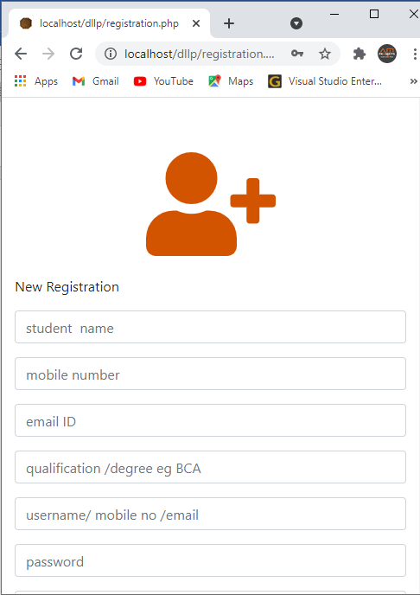

* 1. 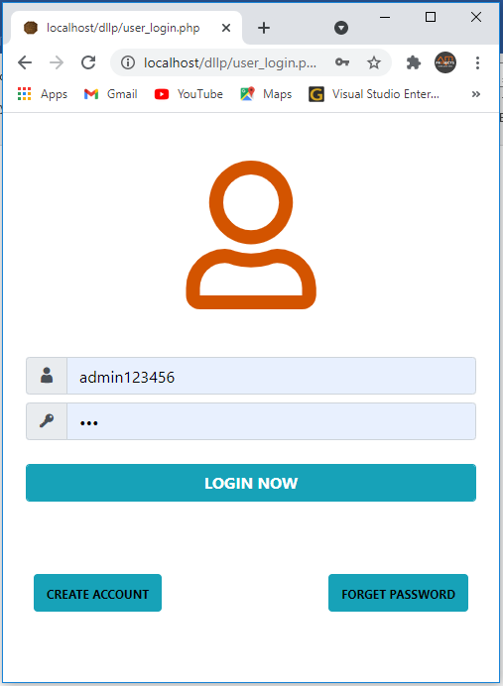**Login**
  2. 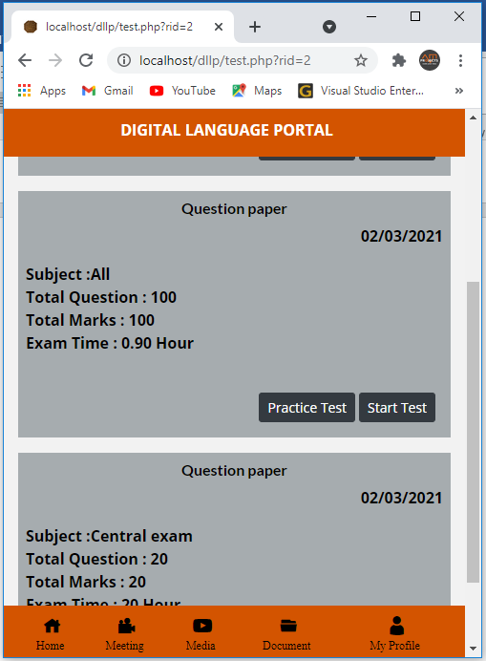**Online Exam**

* 1. **Online Lecture**

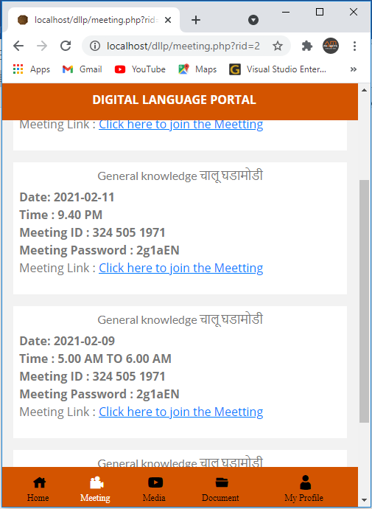

* 1. **Admin Dashboard**

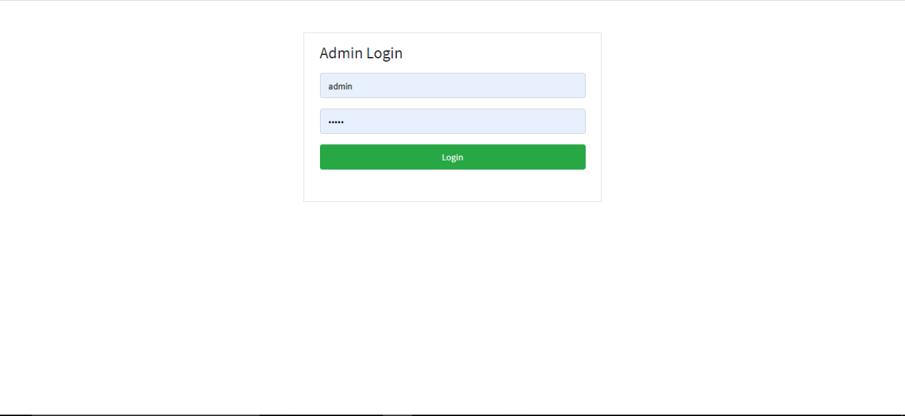

* 1. **Homepage**

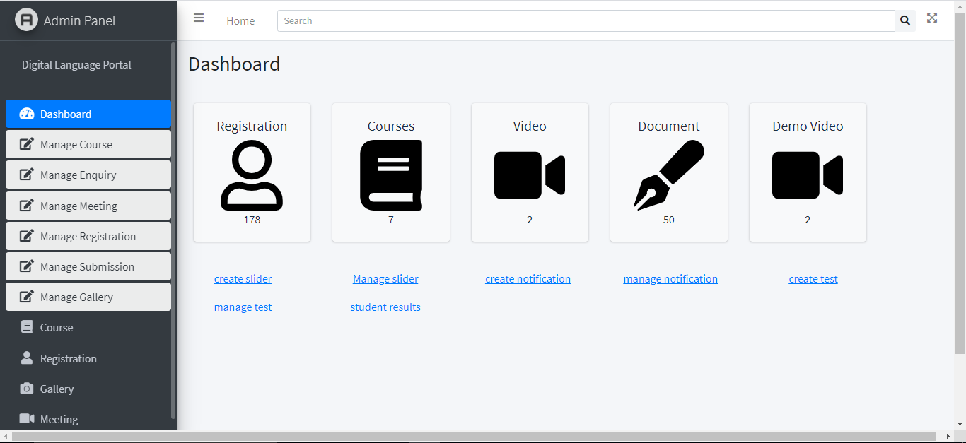

1. **Manage Submission**

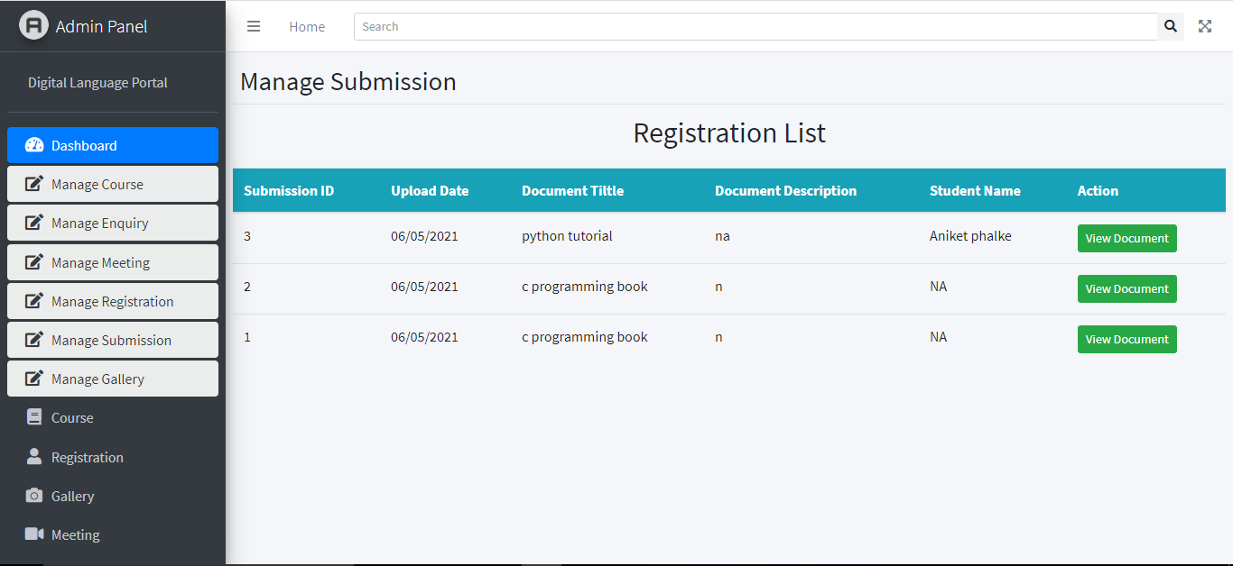

1. **Add Course**

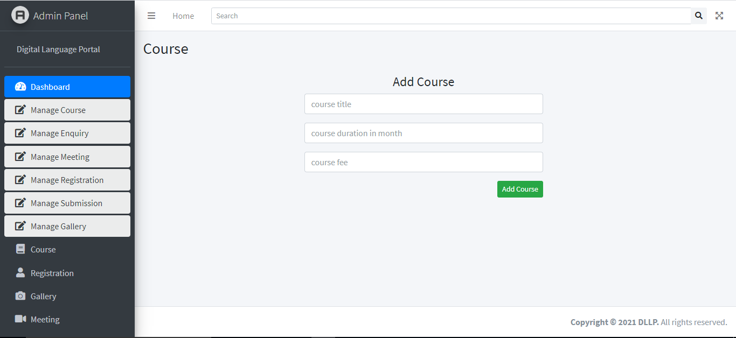

1. **Add Exam**

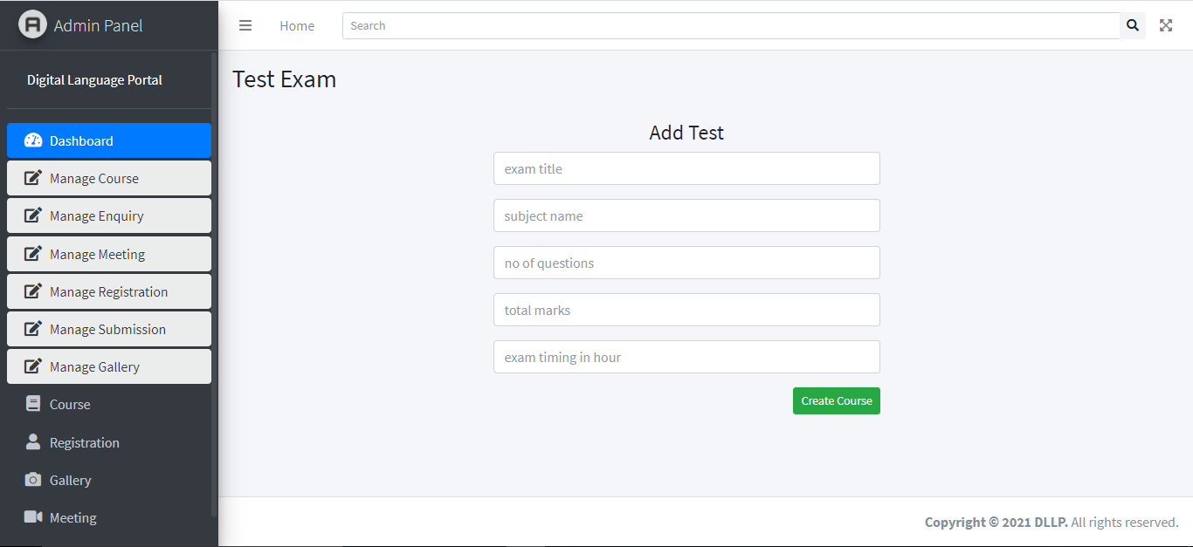

1. **Add Question**

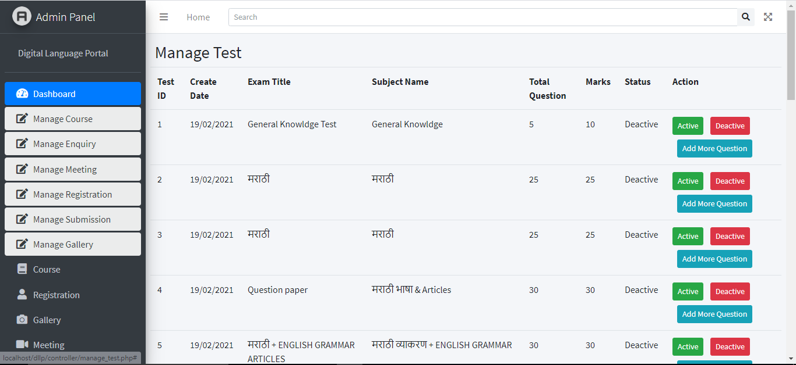

**CONCLUSION**

**Conclusions & Future Work**

Based on the analysis and design of Digital Language Lab Portal, it can be concluded into several points. First, with Online Learning, students have no difficulty in learning. It is because the material can be obtained through this Digital Language Lab Portal (DLLP). These learning materials can be accessed on the portal. Second, in Online Learning, the progress of the learning process can be measured through the features of lesson and quiz. Then, the learning outcomes can be viewed through member dashboard. For further research, the DLLP can be expanded. For example, it can have discussion forum for users to discuss learning materials. Moreover, the future researcher can add online compiler to check the students’ answer.

Limitations

* All PCs should be in a network.
* When PCs are not in same network, internet is required for the connection.
* Poor internet connection may affect the speed of the S/W.

Applications

* Schools
* Colleges
* Institutes
* Universities

**REFERENCES**

**Appendix A:**  Al-Maroof, R. A. S., & Al-Emran, M. (2018). Students’ acceptance of google classroom: An exploratory study using PLS-SEM approach. International Journal of Emerging Technologies in Learning, 13(6), 112-123.

**Appendix B:** Fakhrurrazi M. Amin, Hanna Sundari

English Teaching Department, State Institute for Islamic Studies (IAIN) Langsa, Langsa 24411, INDONESIA and English Education Department, Indraprasta PGRI University, Jakarta 12530, INDONESIA